

**SkyDRM Desktop for Windows**

For Oct Release

Functional Specification Document

Sept 2018

Version 1.0



# Contents

Contents ii

Document Versions 1

Overview 2

Objectives 2

Requirement List 3

Features 11

UI Mockup 13

Class/Module Diagrams 14

Issues and Decisions 15

© 2018 NextLabs, Inc. All Rights reserved.

THE INFORMATION CONTAINED IN THIS DOCUMENT IS PROVIDED"AS IS" WITHOUT ANY EXPRESS REPRESENTATIONS OR WARRANTIES. IN ADDITION, NEXTLABS, INC. DISCLAIMS ALL IMPLIED REPRESENTATIONS AND WARRANTIES, INCLUDING ANY WARRANTY OF MERCHANTABILITY, FITNESS FOR A PARTICULAR PURPOSE, OR NON-INFRINGEMENT OF THIRD PARTY INTELLECTUAL PROPERTY RIGHTS.

This document contains proprietary information of NextLabs, Inc. or under license from third parties. No part of this document may be reproduced in any form or by any means or transferred to any third party without the prior written consent of NextLabs, Inc.

NextLabs, the NextLabs Logo, Compliant Enterprise, ACPL, and the Compliant Enterprise Logo are trademarks or registered trademarks of NextLabs, Inc. in the United States. All other trademarks or registered trademarks are the property of their respective owners.

Document Versions

|  |  |  |  |
| --- | --- | --- | --- |
| Date | Author | Change | Version |
| 9/2018 | Raymond Zeng | Drafted | 1.0 |
|  |  |  |  |
|  |  |  |  |
|  |  |  |  |
|  |  |  |  |

Overview

## Objectives

User can use SkyDRM Desktop to protect native files, upload to MyVault and/or projects, share the files with colleges and friends.

User can view the protected files, which can be attached in a personal email or downloaded from SkyDRM server.

*User can edit the protected files, save back to server, and share with friends. [it is not in Dekstop client]*

# Requirement List

1. Integrate with RPM
   1. Set Login
      * 1. SkyDRM Desktop Login: when user login SkyDRM Desktop, we shall automatically set user login info to RPM.
        2. SkyDRM Desktop Logout: when user logout SkyDRM Desktop, we shall automatically logout RPM.
        3. SkyDRM Desktop Exit: when user exits SkyDRM Desktop (but not logout), we shall automatically logout RPM.
        4. SkyDRM Desktop Restore Last Session: when user restarts SkyDRM and automatically restore last session, we shall automatically set user login info to RPM.
   2. Decrypt
      * 1. We shall use RPM to “decrypt” protect file and our viewer then can use the “decrypted” plain file to view/print.
   3. If NO RPM, we still supports all the features of protect/share/central policies/projects/offline/view…
2. Central Policy
   1. Protect File
      * 1. Give user option to protect file using either ad-hoc policy or central policies. If user select central policies, we shall show the defined classifications to user, and user can select which classifications to be applied to the file.

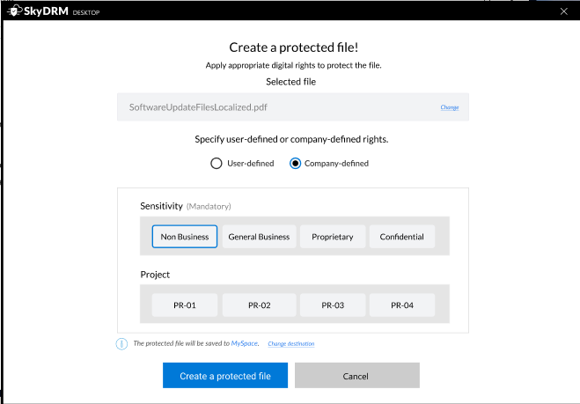

* 1. View File
     + 1. When user views a central policy protected file, we shall evaluate user’s access permission against the file and its classifications, via querying JPC.
  2. View File Info
     + 1. When user views file info, we shall show the pre-set classifications of the file, and show the permission user has on the file.
  3. Classifications/User Attributes
     + 1. We shall sync up the classifications of all tenants(projects) from server, and cache them.
       2. We shall sync up user attributes from server, and cache them.
  4. Central Policy Only
     + 1. When user protects a file, she can’t use ad-hoc policy to protect. The only way is to use central policy to classify and protect file

1. Project
   1. List Project and its Files
      * 1. We shall list projects, and list the files under project for user to view.

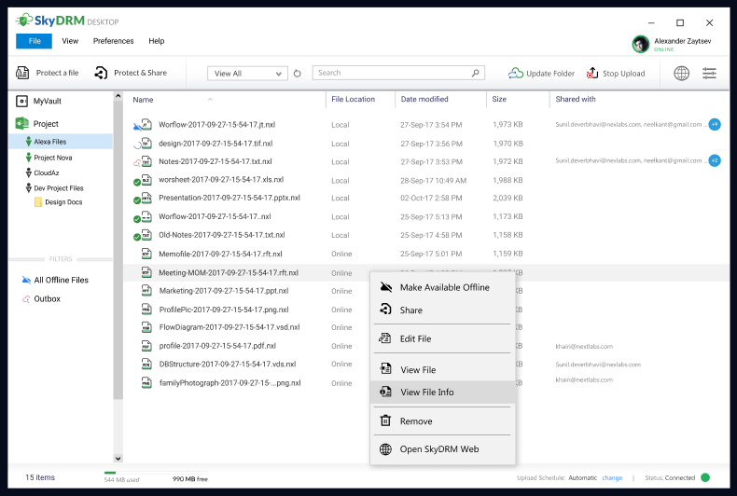

* + - 1. We shall list files under MyVault for user to view.
  1. Protect Files to Project
     + 1. When user protects file via our SkyDRM Desktop client, she can protect and upload file to project.
       2. When user protects file via Windows Explorer right-click menu, she can protect and upload file to project.

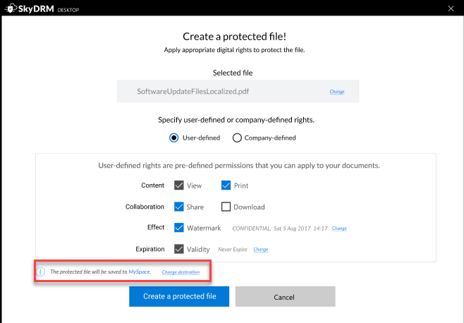

1. Offline
   1. Mark File Offline
      * 1. User can mark the files under project or MyVault as Offline. After that, we shall cache/download the files from server for offline view. User can also remove the offline files from local cache.
   2. View Offline File
      * 1. If the file is already marked as offline, when user wants to view the file, we shall open the local cached file to our Viewer to render the file.

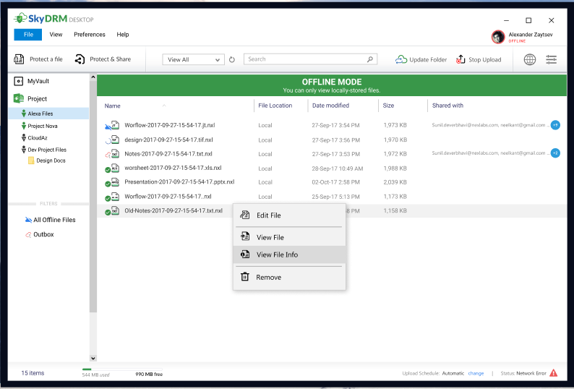

1. Edit
   1. Edit Office (Word, Excel, PPT)
      * 1. User can edit the protected office file, and save back to the protected office file.
        2. If user wants to save as the open protected office file via Office native application, this action will be blocked.
   2. Edit CAD
2. Enhanced NXL File Handling
   1. Hoops to View CAD
      * 1. If we don’t use Communicator to convert CAD file, we shall call RMS to convert when online. Or when user marks the file as offline, before downloading, RMS shall convert the protected CAD file to a new protected HSF file, and then download the protected HSF file.
        2. If we still use Communicator to convert CAD file, we shall use Communicator Libraries, instead of pre-bound Converter.exe application.
   2. .NXL File Handler
      * 1. When user double-clicks a .NXL file from Windows Explorer, or from an attachment of an email, our SkyDRM Desktop shall popup to view the file. We need to handle both login and not login situations.
   3. Inplace Protect
      * 1. When user right-click a file via Windows Explorer, user can protect the file and save the new protected NXL file under the same location as original plain file. And it will not be added to our Desktop main window to do upload to MyVault/Project.
           1. The original plain file will be removed.
        2. User can still copy the new protected NXL file to our Desktop main window (under MyVault) and do upload.
   4. Cancel Upload/Download
      * 1. When uploading file to RMS or downloading from RMS, user can cancel the upload/download manually.
   5. Protect Multiple Files
      * 1. User can select multiple files to protect/share in one operation.
        2. This indicates current SDK shall support multi-threads protection in one execution context, especially for the serialization (currently we save to file).
   6. Change DecryptFile API for Viewer if no RPM
      * 1. If we support NO RPM, we need to use the new API to replace current DecryptFile API and get the file stream of raw file content to view file.
3. SSO
   1. SSO
      * 1. We shall use Windows login credential to login RMS.
        2. If there is one instance of SDK already logins, we shall directly use that login credential to login RMS.
4. Misc
   1. User Profile/Setting Window
      * 1. User can set default WaterMark/Expiratioin in Profile Window.
        2. User can set personal picture in Profile Window.
        3. User can change password in Profile Window

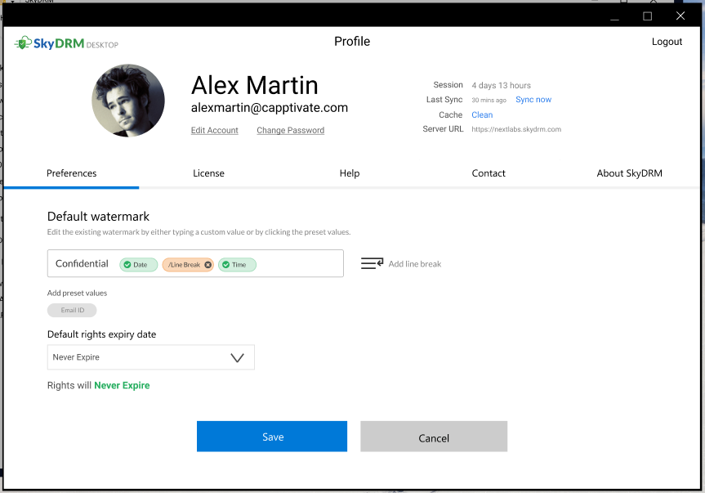

* 1. Local Help Files
     + 1. When user clicks the help, we shall show the local help files in Help Window (part of Profile Window).

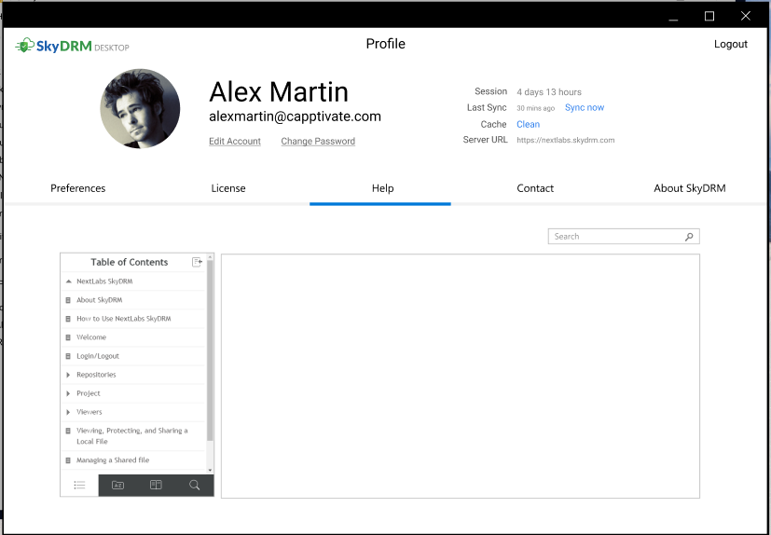

* 1. Auto-Discovery of SkyDRM On-Premise Server
     + 1. When user starts SkyDRM Desktop to login, before user inputs the On-Premise server URL, we shall auto-discover the existing RMS servers and show it in the input box.
  2. Upgrade Online
     + 1. When user clicks “Upgrade Online” menu item, we shall check the latest version of clients of selected SkyDRM RMS server. And if there is a newer version, we shall prompt user to upgrade.

1. Installation
   1. SCCM Installation (Silent Mode)
      * 1. SCCM to publish SkyDRM Desktop to all clients, with pre-defined Router URL.
2. Integration
   1. Be compatible with EDP (WDE/OE) 8.5

# Features

|  |  |  |  |
| --- | --- | --- | --- |
| **Area** | **Feature** | **Description** | **Priority** |
| **RPM** | Set Login | Set RPM Login/Logout when user login/logout SkyDRM Desktop | P0 |
| **RPM** | Decrypt | Use RPM to “decrypt” file for view | P0 |
| **RPM** | Support without RPM | Without RPM, SkyDRM Desktop uses RMD-SDK to protect/share/view files | P1 |
| **JPC** | Protect Central Policy File | Give user option to protect central policy file with classifications | P0 |
| **JPC** | View Central Policy File | Evaluate the policy against file classifications and user attributes when view file | P0 |
| **JPC** | View Central Policy File Info | Show the defined classification for central policy file info | P0 |
| **JPC** | Sync Classification/Attriburtes from RMS | Get classificatioins of tenants(projects) and user attributes from RMS | P0 |
| **JPC** | Central Policy Only | Can’t use ad-hoc policy to protect file | P2 |
| **Project** | List Project and Files | List projects and files under project in Desktop main window | P0 |
| **Project** | Protect File to Project | User can protect a file to project | P0 |
| **Offline** | Mark as Offline | User can mark the file as offline and cache it to local | P0 |
| **Offline** | View Offline Files | User can view the cached offline file | P0 |
| **Edit** | Edit Protected Office Files | User can use native Office application to edit protected office files, supporting Office2013 and Office2016. | P1 |
| **Enhanced Handling** | NXL File Handler | User can view forwared/downloaded NXL files | P0 |
| **Enhanced Handling** | Inplace Protect | User protects the files without upload to MyVault | P2 |
| **Enhanced Handling** | Cancel Upload/Download | User can cancel the upload/download files from RMS | P1 |
| **Enhanced Handling** | Protect Multiple Files | User can select multiple files to protect.  SDK shall do serialization gracefully (to DB). | P1 |
| **Enhanced Handling** | Hoops Convert in RMS | Before downloading the offline CAD file, RMS converts the CAD file to a new protected HSF file | P1 |
| **Enhanced Handling** | Hoops Library | Replace current Hoops converter.exe to convert CAD file to HSF file | P2 |
| **Enhanced Handling** | Change DecryptFile API | Decrypt file content to a file stream | P1 |
| **SSO** | SSO | Use Windows credential to login RMS | P1 |
| **Misc** | User Profile Window | User can set default watermark, expiration setting, change password, picture… | P1 |
| **Misc** | Local Help | We will show local help html file instead of online help URL | P1 |
| **Misc** | Auto-Discovery | Automatically find the on-premise RMS to ease user to input RMS server URL | P2 |
| **Misc** | Upgrade Online | Upgrade SkyDRM Desktop online | P2 |
| **Install** | SCCM Installation | SCCM to publish Desktop clients to machines, with pre-set router URL | P1 |
| **Compabitlity** | Be compabile with EDP 8.5 | Can work with WDE/OE 8.5 | P2 |
|  |  |  |  |

# UI Mockup

See Figma:

<https://www.figma.com/file/Ikpe8E2ROt0Qxlh5BXZ74e/SkyDRM-Local---Windows10-OS?node-id=15746%3A739>

# Class/Module Diagrams

# Issues and Decisions

#1: SkyDRM Desktop supports with/without RPM same time?